**Experiment : 2.3**

**Student Name: SANJIV GUPTA UID:** 21BCS-*3478*

**Branch:** CSE **Section/Group:** 21BCS-IOT-602B

**Semester:** 5th **Date:** 20/10/23

**Subject Name**: Advanced Programming LAB **Subject Code:** 21CSP-314

**AIM:**

*String Algorithms: Demonstrate the concept of string.*

**OBJECTIVE:**

*1).* *A pangram is a string that contains every letter of the alphabet. Given a sentence determine whether it is a pangram in the English alphabet. Ignore case. Return either pangram or not pangram as appropriate.*

*2.) There is a sequence of words in CamelCase as a string of letters,s , having the following propertie:*

*1).It is a concatenation of one or more words consisting of English letters.*

*2).All letters in the first word are lowercase.*

*3).For each of the subsequent words, the first letter is uppercase and rest of the letters are lowercase.*

*Given s, determine the number of words in s.*

**CODE:**

**Code 1:**

*import math*

*import os*

*import random*

*import re*

*import sys*

*def pangrams(s):*

*return ("not pangram", "pangram")[len(set(s.lower().replace(" ", ""))) == 26]*

*if __name__ == '__main__':*

*fptr = open(os.environ['OUTPUT_PATH'], 'w')*

*s = input()*

*result = pangrams(s)*

*fptr.write(result + '\n')*

*fptr.close()*

**Code 2**

*int camelcase(string s) {*

*int n = s.length();*

*int count = 0;*

*for(int i = 0; i < n; i++){*

*if(s[i] >= 'A' && s[i] <= 'Z'){*

*count++;*

*}*

*}*

*return count+1;*

*}*

*int main()*

*{*

*ofstream fout(getenv("OUTPUT_PATH"));*

*string s;*

*getline(cin, s);*

*int result = camelcase(s);*

*fout << result << "\n";*

*fout.close();*

*return 0;*

*}*

**OUTPUT:**

**OUTPUT 1**

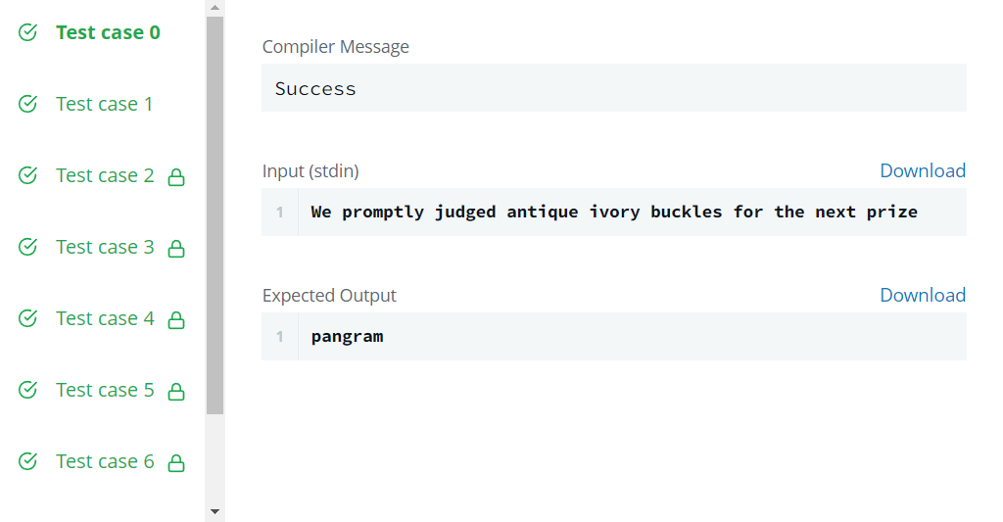

**OUTPUT 2**

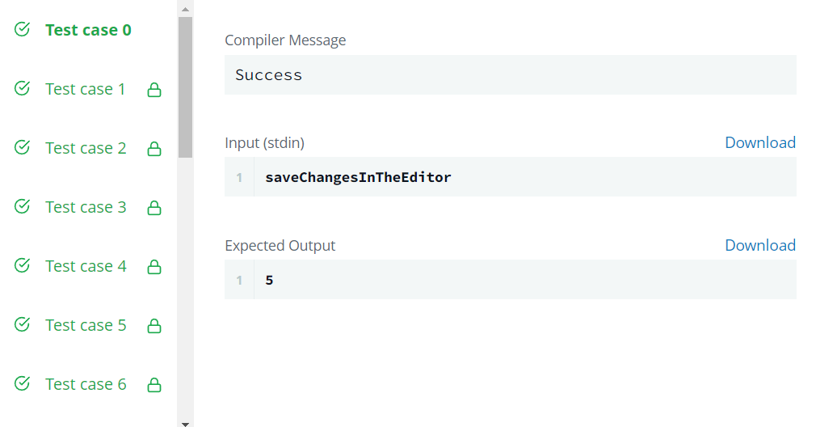

**LEARNING OUTCOMES:**

1. *Understood the concept of String.*
2. *Understood the concept how to search in String and perform different operations.*
3. *Learn about algorithm thinking*
4. *Learn about mathematical logic*